Abstract.

Obesity has become a significant global public health concern due to its association with numerous chronic diseases including cardiovascular disease, diabetes, stroke, and certain types of cancer. The objective of this study was to investigate the key lifestyle, behavioural, and physical factors influencing obesity levels using machine learning techniques applied to an obesity dataset. The dataset consisted of demographic, dietary, and lifestyle variables such as age, height, weight, physical activity frequency, vegetable consumption, water intake, smoking habits, alcohol consumption, and transportation methods. The target variable in the dataset was the obesity classification level (NObeyesdad), which categorizes individuals into different obesity groups ranging from insufficient weight to obesity type III.

The research employed a structured methodological approach beginning with exploratory data analysis to understand the distribution, relationships, and patterns within the dataset. Various visualisation techniques including box plots, histograms, density plots, and correlation heat maps were used to identify relationships between variables. Dimensionality reduction techniques such as Principal Component Analysis (PCA) were applied to determine the most influential components explaining variance within the dataset. Additionally, data transformation techniques including Tukey transformation and Shapiro–Wilk normality tests were conducted to assess distributional properties of the variables.

Two machine learning approaches were implemented in this study: regression and classification. Linear regression models were used to examine the relationships between predictors such as age, height, and weight and their influence on obesity classification. The regression analysis revealed that weight was the most significant predictor of obesity level, while age also showed a positive association with increasing obesity categories. Height demonstrated a negative relationship with obesity levels. The regression model explained approximately 33.8% of the variance in obesity classification, indicating that while these factors are important predictors, other behavioural and environmental variables may also contribute to obesity outcomes.

A classification model using the K-Nearest Neighbours (KNN) algorithm was also implemented to predict obesity categories based on the dataset features. The dataset was split into training and testing subsets using an 80/20 split. Model evaluation using confusion matrices showed strong predictive performance for certain obesity classes, particularly Obesity Type II, although the model struggled to accurately classify some higher obesity categories such as Obesity Type III. These results demonstrate both the potential and limitations of classification models in predicting complex health conditions.

Further analysis involved feature engineering techniques to construct additional behavioural indicators such as a lifestyle score, eating behaviour index, and activity ratio. These derived variables combined multiple lifestyle factors to better represent behavioural patterns associated with obesity. Visualisation of these engineered features revealed that individuals with lower activity ratios and poorer dietary behaviours tended to fall into higher obesity categories.
The findings from this study confirm that obesity is influenced by multiple interacting factors including body weight, age, dietary habits, physical activity levels, and sedentary behaviours. The use of machine learning techniques provided valuable insights into the predictive relationships between these variables and obesity outcomes. However, the study also highlights the complexity of obesity as a multifactorial condition that cannot be fully explained by a single model or limited set of predictors.

Overall, this research demonstrates the usefulness of combining exploratory data analysis, regression modelling, classification algorithms, and feature engineering to better understand patterns associated with obesity. The findings emphasise the importance of promoting healthier lifestyles, increased physical activity, and improved dietary habits as key strategies for reducing obesity prevalence. Future research may benefit from incorporating more advanced machine learning algorithms and additional behavioural or environmental variables to further improve predictive performance and deepen understanding of obesity determinants.

Introduction.
The topic of my assignment work is Estimation of Obesity levels Based on eating habits and physical condition.
I am carrying out a machine learning supported research on the most important variables that affected obesity levels (positively or negatively).
Obesity is a health problem where a human being has a disproportionate amount of body fat that can cause many health problems ranging from heart disease, inability to stand and walk properly and even sexual impotence.

The obesity dataset is comprised of variables with their meanings as explained below:
1. Demographic Variables

1. Gender

Type: Categorical

Meaning: Biological sex of the individual

Values:

Male

Female

2. Age

Type: Numerical (continuous)

Meaning: Age of the individual in years

3. Height

Type: Numerical (continuous)

Meaning: Height of the individual in meters

4. Weight

Type: Numerical (continuous)

Meaning: Weight of the individual in kilograms

2. Family / Genetic Factor

5. family_history_with_overweight

Type: Binary categorical

Meaning: Whether the person has family members with overweight/obesity

Values:

yes

no

This represents genetic predisposition to obesity.

3. Eating Habit Variables

6. FAVC

Meaning: Frequent consumption of high-calorie food

Type: Binary categorical

Values:

yes

no

7. FCVC

Meaning: Frequency of vegetable consumption

Type: Numerical (ordinal scale 1–3)

Interpretation:

1 = rarely

2 = sometimes

3 = always

8. NCP

Meaning: Number of main meals per day

Type: Numerical

Typical values:

1

2

3

4+

9. CAEC

Meaning: Consumption of food between meals (snacking)

Type: Categorical

Values:

no

sometimes

frequently

always

10. CALC

Meaning: Alcohol consumption

Type: Categorical

Values:

no

sometimes

frequently

always

4. Lifestyle Variables

11. SMOKE

Meaning: Whether the person smokes

Type: Binary categorical

Values:

yes

no

12. CH2O

Meaning: Daily water consumption

Type: Numerical (scale 1–3)

Interpretation:

1 = low

2 = moderate

3 = high

13. SCC

Meaning: Calories consumption monitoring

Type: Binary categorical

Values:

yes (person tracks calories)

no

14. FAF

Meaning: Physical activity frequency

Type: Numerical (scale 0–3)

Interpretation:

0 = none

1 = low

2 = moderate

3 = high

15. TUE

Meaning: Time spent using technology devices (TV, phone, computer)

Type: Numerical (0–2 scale)

Interpretation:

0 = low screen time

1 = moderate

2 = high screen time

16. MTRANS

Meaning: Mode of transportation used

Type: Categorical

Values include:

Walking

Bike

Public Transportation

Automobile

Motorbike

This indirectly measures physical activity level.

5. Target Variable (What the model predicts)

17. NObeyesdad

Meaning: Obesity level classification

Type: Categorical

Classes:

1. Insufficient_Weight

2. Normal_Weight

3. Overweight_Level_I

4. Overweight_Level_II

5. Obesity_Type_I

6. Obesity_Type_II

7. Obesity_Type_III

This is the dependent variable.
As defined by the World Health Organisation (WHO), obesity is abnormal or excessive fat accumulation that presents a risk to health.
A crude measure of obesity is the body mass index (BMI), which is measured by calculating a person’s weight (in kilograms) divided by the square of his or her height (in metres). A person with a BMI of 30kg.m2 or more is generally considered to be living with obesity. Obesity is a risk factor for several chronic diseases, including diabetes, cardiovascular diseases and cancer. Obesity UK (2024). What is Obesity? - Obesity UK. [online] Obesity UK. Available at: https://obesityuk.org.uk/what-is-obesity/.

Many people have suffered debilitating health problems from this obesity disease, and some have lost their lives or sexual potency in the cause of suffering from obesity.
Obesity also increases the risk of stroke.
Most terminal diseases can be amplified when one is obese, and this tells us that obesity increases early human mortality.
Early preventive measures and healthy lifestyle can prevent or reduce the risk of one suffering from this issue.

Why is research on diet, obesity and nutrition important?
Around 1 in every 4 adults in the UK is obese. Obesity increases the risk of type 2 diabetes, heart disease, some cancers and stroke. Research into diet, obesity and nutrition is important as it can help us manage these risks and encourage people to make healthy choices. NIHR Evidence. (n.d.). Diet, Obesity and Nutrition research. [online] Available at: https://evidence.nihr.ac.uk/nihrcategory/diet-obesity-nutrition/.
‌The history of obesity, both as a medical condition and in literature, is rich and multifaceted. Obesity has been present throughout human history, but it has been understood and portrayed in varying ways depending on cultural, social, and medical perspectives. Below is a timeline and a brief look at how obesity has evolved in the literature and medical fields.

Timeline of Obesity’s History

Ancient Times (Pre-500 AD)
Ancient Greece & Rome: Obesity was seen as a sign of wealth and indulgence in some cultures. Philosophers such as Hippocrates (460–370 BC) acknowledged that excessive body weight could have negative effects on health but still viewed it as a matter of excess pleasure, particularly among the upper classes.
Roman Empire: Roman writers like Juvenal satirized the excesses of wealthy individuals, linking obesity with gluttony. Some Roman physicians, including Galen, believed that an imbalance of bodily humours caused obesity.
Medieval Period (500–1500 AD)
Religious and Cultural Views: Obesity during this time was less frequently discussed in medical texts but was often linked to overindulgence in food, a vice associated with the sin of gluttony. In Christian theology, excess body weight was often portrayed as a spiritual failing.
Social Structure: The medieval period largely saw obesity as a marker of social class, with the wealthy able to afford abundant food.
Early Modern Period (1500–1800 AD)
Renaissance Era: Artists like Peter Paul Rubens depicted women with fuller figures, often portraying them as symbols of fertility and beauty. Obesity was still associated with affluence.
Scientific Revolution: Early studies began to emerge about the role of diet and exercise in maintaining health, but obesity was still not treated as a medical disorder in the modern sense. The idea that overeating could cause disease started to gain traction.
19th Century
Industrial Revolution: With the rise of the industrial era and urbanization, a more standardized approach to diet and physical activity began to emerge. People from lower social classes, who had less access to food, were often leaner, and obesity became increasingly associated with the wealthy.
Medical Understanding of Obesity: In the late 1800s, Sir William Banting, an English undertaker, published a pamphlet titled “Letter on Corpulence”, which outlined his personal weight loss regimen. This marks one of the first attempts at a systematic approach to dieting, sparking interest in reducing weight through calorie restriction.
20th Century
1920s–1940s: Obesity was more widely recognized in medical literature as a health problem. During this time, the concept of “obesity as a disease” started to take hold. The term “obesity” itself gained medical and social significance.
1950s–1970s: With the rise of consumer culture and mass media, obesity became a popular topic in both medical and popular literature. Weight loss became an industry, with products like weight loss pills and exercise equipment emerging.
1970s–1980s: Obesity continued to be seen as a medical problem, with research focusing on the metabolic and hormonal factors that contribute to weight gain. Obesity rates began to rise significantly during this period, leading to greater public awareness.
1972: The term Body Mass Index (BMI) was introduced by Adolphe Quetelet, which became a widely used metric for determining obesity based on weight and height. However, BMI was a somewhat controversial measure, as it does not account for muscle mass or fat distribution.
Late 20th Century to Present
1990s–2000s: The World Health Organization (WHO) declared obesity a global epidemic in 1997. In the 2000s, the obesity epidemic became a central focus in public health literature.
2010s-Present: The focus on obesity shifted from purely personal responsibility to a more nuanced understanding, including the influence of genetics, the environment, and socioeconomic factors. The rise of GLP-1 agonists and other pharmacological treatments for obesity furthered scientific research in metabolic health. Cancerobesityconnection.org. (2025). ⚖️ The History of Obesity – CancerObesityConnection.org. [online] Available at: https://cancerobesityconnection.org/the-history-of-obesity/.

From the above referenced article, we see that obesity as a health problem has been around for a long time, dating back to when people saw it as a symbol of wealth and affluence. This was due to a knowledge gap on the negative health repercussions of it. It then evolved to be seen as a sign of ‘gluttony’ from a religious perspective because the holy book says in Proverbs chapters 25 verse 16 ‘If you have found honey, eat only enough for you, lest you have your fill of it and vomit’.
Moving on, it became a symbol of beauty and attractiveness in women, of which if medical science had evolved faster and people were made to see the risks of obesity to pregnant women and their fertility, the school of thought of obesity being seen as a ‘beauty mark’ wouldn’t be adopted.
It was in the early 20th century (thanks to medical science advancement) that obesity started being seen as a health problem and people started looking for ways to dissociate from it.

The aim of this machine learning task is to critically examine the chief factors responsible for obesity in humans and proffer recommendations on how to mitigate the risk.
We will adopt two machine learning models which are Classification and Regression. In doing so, we will apply exploratory data analysis to see how each of the variables in the dataset contribute strongly or weakly to obesity.
Dimensionality reduction techniques will be used to pick out the most important variables from the rest of the variables in the obesity dataset.
After which carefully thought-out recommendations will be provided to checkmate the problem of obesity.

Literature review.
In this chapter, we aim to define the variables and explain their degree of importance to the problem of obesity with relevant references.
First off, we start with examining how obesity affects age or aging.

How does obesity affect aging?
1. Obesity increases inflammation and the risk of age-related diseases
Inflammation is our body's way of fighting off injury or infection. But when it lasts too long or happens too often, it can cause harm. Chronic, low-grade inflammation is an innate part of the aging process, referred to as “inflammaging.” Inflammaging is linked with an increased risk for disease.
Systemic inflammation is also common in people with obesity. Over time, obesity-related inflammation can make age-related diseases appear earlier and progress more quickly. These include:
  - Insulin resistance, which can lead to type 2 diabetes
  - Heart disease and stroke, since inflammation damages blood vessels
  - Certain types of cancer, since long-term inflammation can cause abnormal cell growth
  - Neurodegenerative diseases like dementia and Parkinson’s disease
✅ How to reduce chronic inflammation
Getting your weight into a healthier range can ease chronic inflammation and protect your health. What you eat matters, too. Try to focus on anti-inflammatory foods such as salmon, tofu, soybeans, walnuts, grapes, and blueberries (and limit red meats and processed foods). It's also important to keep your blood sugar in check, manage stress, and stay physically active.
2. Obesity makes mobility problems more likely
Staying active is one of the most important things we can do to age with vitality and independence. Obesity makes this challenging by increasing the risk of muscle loss and joint damage.
Obesity may directly cause mobility challenges—or it may intensify mobility issues brought on by aging. This happens through:
  - Muscle wasting: Both aging and obesity contribute to the loss of skeletal muscle mass and strength, otherwise known as sarcopenia. Sarcopenia can affect our ability to walk, stand, get out of a chair, or use stairs. It also increases the risk for falls and bone fractures.
  - Impaired balance: Due to a natural decline of the senses, some older adults may have trouble with balance and coordination. Extra weight can worsen these challenges, increasing the chance of falls and serious injuries. An older study uncovered a 25% to 31% higher risk of falls in older adults with obesity compared to those in a normal weight range.¹
  - Added stress on joints: Osteoarthritis (OA) risk increases as we get older. Obesity is also a big risk factor for OA due to the added pressure on joints—especially in the knees, hips, and lower back. “Excess body weight increases the wear and tear on joints and makes discomfort worse for people who have degenerative joint disease,” bariatric surgeon Emil Graf, MD, told Banner Health.
Older adults with obesity are more likely to need joint replacements. One study found that patients with obesity had a 100% increased risk of knee replacement surgery compared to patients of a normal weight.²
✅ How to protect your mobility
Research has shown that even a 10% weight loss can result in less pain, greater function, and a better quality of life while reducing inflammation and further stress on joints.³ In addition to achieving and maintaining a healthy weight, you can protect your mobility by:
  - Doing exercises that support strength, balance and flexibility (e.g., yoga, tai chi)
  - Engaging in aerobic activity 30 minutes a day, five days a week (e.g., walking, swimming, biking)
  - Performing stretching and strength training exercises three times per week
3. Obesity can shorten our life, starting at the cellular level
Many people think of aging in terms of physical appearance—like glimmers of silver in our hair. But aging also happens inside the body at the cellular level. Scientists now know obesity can speed up this cellular process.
Epigenetics is the study of how our habits and environment can change how our genes work—without altering our DNA. “Epigenetic age” is recognized as a health marker that can predict disease and mortality risk.
Research has linked weight gain with higher epigenetic aging. In fact, one study of middle-aged participants showed that obesity speeds up age-related epigenetic changes in the human liver. Scientists found that for every 10-point increase in body mass index (BMI), the liver aged an extra 2.7 years.⁴
What does this mean for people living with obesity? It means they may experience age-related decline earlier than those with a healthy weight. These physiological changes can increase the risk of diseases associated with aging, such as heart disease and metabolic disorders (e.g., diabetes).
✅ How to boost your ability to age well
While you can’t stop the hands of time, you can focus on aging in good health. This means managing your weight; eating nutrient-dense, high-antioxidant foods; and staying active. These habits can help protect your body’s cells and prevent your organs from aging faster than you do.
4. Obesity boosts the risk of dementia and memory issues
One of the most alarming effects of obesity on aging is its impact on brain health. Studies reveal that people with obesity are more likely to develop dementia, including Alzheimer’s disease.
A recent study at McGill University found that patterns of brain shrinkage in people with obesity are comparable to brain changes seen in people with Alzheimer’s. Researchers concluded that people with excess weight and obesity could potentially slow cognitive decline by achieving a healthy weight.⁵
Scientists aren't fully clear on how obesity affects the brain. One theory is that chronic inflammation caused by obesity causes structural damage in the brain as well as damage to brain cells. Excess weight is linked to higher blood sugar and insulin resistance, both known risk factors for dementia.
✅ How to protect your brain as you age
By focusing on a healthy weight and healthy habits, you can lower your risk of cognitive decline and protect your brain function.
Lifestyle habits that support brain health include:
  - Eating a brain-healthy diet (rich in fruits, vegetables, and healthy fats)
  - Keeping physically active
  - Getting quality sleep
  - Managing your blood sugar and blood pressure
  - Limiting alcohol use
- Ncoa.org. (2025). How Does Obesity Affect Aging? [online] Available at: https://www.ncoa.org/article/4-surprising-ways-obesity-affects-aging/.
We see from the above referenced article that obesity leads to fat accumulation in and around the heart which makes the heart experience intense difficulty when pumping blood to the rest of the body, which can lead to sudden heart attack and other chronic heart related diseases.
We also see that as humans age; obesity can make walking difficult if their joint muscles get overburdened from carrying the weight of their body.
We also see that chronic inflammation caused by obesity can also cause brain damage leading to Alzheimer’s disease.
Next up, we examine the role physical activity plays in managing obesity.
Physical activity plays a crucial role in managing obesity by improving body composition, supporting weight maintenance, and enhancing overall physical and mental health, even when weight loss is modest.

Impact on Weight and Body Composition
Regular physical activity, including both aerobic and resistance exercise, can lead to reductions in body weight, fat mass, and waist circumference, particularly when combined with dietary interventions. Exercise alone typically produces modest weight loss (around 2–4 kg), but when paired with caloric restriction, additional weight loss of approximately 6 kg can be achieved. Importantly, physical activity helps preserve lean body mass during weight loss, which is critical for maintaining metabolic health and physical function.

Cardiometabolic and Health Benefits
Even without significant weight loss, physical activity improves cardiovascular risk factors, including blood pressure, insulin sensitivity, and lipid profiles. It also reduces the risk of type 2 diabetes, stroke, heart disease, and certain cancers by 20–30% and can extend lifespan by several years. Exercise enhances muscle strength, mobility, and cardiorespiratory fitness, which is particularly beneficial for older adults or those with severe obesity. Boulé, N. and Prud'homme, D. (n.d.). Canadian Adult Obesity Clinical Practice Guidelines 1 KEY MESSAGES FOR HEALTHCARE PROVIDERS Physical Activity in Obesity Management. [online] Available at: https://obesitycanada.ca/wp-content/uploads/2025/03/9-Canadian-Adult-Obesity-CPG-Physical-Activity.pdf.
‌From the above referenced article, we see that physical activity plays two important roles in mitigating the adverse effects of obesity.
First off, physical activity helps maintain a regular body mass index which boosts body metabolism and even psychological, social and mental confidence.
Physical activity also helps prevent cardiovascular diseases by boosting cardiorespiratory fitness which reduces the risk of heart related diseases like stroke or cardiac arrest.
Next up, we look at how eating habits influence or affect obesity.
Lifestyle choices possess imperative roles in determining obesity. For example, many studies have demonstrated that excess intake of calorie-dense foods with a sedentary lifestyle is a primary contributing factor, but the etiology of obesity is particularly complex (Aronne et al., 2009[2]). For instance, obesity has been linked to other behaviors, such as disruption of biological rhythms. These rhythms are controlled by internal clocks in the human body orchestrated by the circadian system. The central clock is located in the brain and is regulated by the day/night cycles (Berson et al., 2002[3]). Disruption of this clock through alterations in light/dark cycles, such as in night-shift workers, has been associated with metabolic dysfunction (Swanson et al., 2016[24]; Takiishi et al., 2017[25]; Voigt et al., 2014[26], 2016[27]).
The peripheral clock in the intestine, on the other hand, is essentially controlled by eating time (Stenvers et al., 2012[22]). We and others have shown that eating at times misaligned with the light/dark cycles, such as during and close to rest time, leads to central-peripheral dyssynchrony and circadian disruption in mice (Bishehsari et al., 2020[5]). Furthermore, our recent animal study illustrated that this discordance between eating time and light cycle with irregular eating habits between weekdays and weekends predisposes mice to weight gain. Such a behavior is a relevant characteristic of the modern human lifestyle since individuals commonly consume larger meals in the evenings closer to rest/dark phases (Takiishi et al., 2017[25]; Voigt et al., 2014[26], 2016[27]). However, the role of consistency in mealtimes has yet to be thoroughly explored. Here, we aimed to examine if inconsistent eating times are associated with obesity. Adnan, D., Trinh, J. and Bishehsari, F. (2022). Inconsistent eating time is associated with obesity: A prospective study. EXCLI journal, [online] 21, pp.300–306. doi:https://doi.org/10.17179/excli2021-4324.
‌From the above referenced article, we see that excessive intake of high calorie foods is a primary contributor to obesity and as such must be discouraged.
We also see that heavy late-night food also makes one prone to obesity, and as such humans must endeavour to eat light foods as dinner before night falls. Intermittent fasting is also encouraged as it will give the body enough time to carry out proper metabolism and detoxification.
Next up, we will look at how smoking affects obesity.

Why smoking might increase visceral fat
Lauren Mahesri, RDN, LD, from The Pediatric Dietitian, explained that the connection between smoking and a variety of metabolic disorders — such as high cholesterol, insulin resistance, high blood pressure, and type 2 diabetes — is well known.
“Although the mechanism of this connection is not fully understood, it’s likely that
these metabolic disorders are the connection between smoking and increased visceral fat,” she stated.
Mahesri also noted that although the study controlled for certain behavioral factors — like alcohol consumption, exercise, and dietary intake — smoking, poor diet, and a sedentary lifestyle can all contribute to the formation of visceral fat.
Jessie Dickinson, RD, from Nudj Health, further stated that the nicotine in tobacco is directly correlated with cholesterol levels.
“Smoking can raise LDL cholesterol levels (bad cholesterol) and lower HDL cholesterol levels (good cholesterol),” she said, adding that visceral fat is directly linked with high total and LDL cholesterol, low HDL cholesterol, insulin resistance, and metabolic syndrome.
“Overall, most findings suggest that there should be an emphasis on the risk of increased visceral fat (central obesity), insulin resistance, and associated conditions among smokers,” she stated. Healthline. (2024). Smoking May Contribute to Increased Belly Fat. [online] Available at: https://www.healthline.com/health-news/smoking-may-lead-to-weight-gain-increased-belly-fat#Why-smoking-might-increase-visceral-fat.

The above referenced article shows us that nicotine (which is a highly addictive substance contained in tobacco) increases cholesterol levels and visceral fat (abdominal fat that surrounds the intestines, liver and pancreas) is linked to high cholesterol levels.

Next up, we look at how drinking water (CH2O) can affect obesity.

Does Water Boost Your Metabolism?
Your metabolism is all the chemical reactions that happen in your body to keep you alive. "High" metabolism means your body burns calories quickly, and "low" metabolism means it burns them more slowly. Doctors call this your metabolic rate.
How much water you drink has a direct impact on your metabolism. Water is a critical part of your body's enzyme activities and biochemical reactions, including:
- Glycolysis, or the breaking down of glucose for energy
- Beta-oxidation, which is the burning of fat
- Protein synthesis, the process where cells make protein
Certain organs that play a part in metabolism need water to work well, including your liver and kidneys. Ellis, R.R. (2025). Does Drinking Water Help You Lose Weight? [online] WebMD. Available at: https://www.webmd.com/obesity/drinking-water-lose-weight.

From the above referenced article, we see that drinking water improves body metabolism (which is the natural process by which your body burns fat through sweat pores) and when the body is dehydrated, the liver is put under pressure to do more work which can increase the risk of liver failure.

Chapter 3. A critical summary of my overall methodological approach.
I started my research work by stating the topic of my research problem in a simplified way that makes it easy to understand for any literate reader. I then proceeded to do a brief introduction of my intended work which involved describing the research problem, which is obesity, looking at the potential factors that cause obesity and the adverse effects of obesity on overall health.

I then presented all the variables in my dataset (both the target variable and the features) and explained what their acronyms stood for and the nature of the variables (whether they be numerical or categorical). Doing this will help the grader to conceptualize my work and flow with my reasoning pattern.

I then made a brief historical overview of obesity and explored how it evolved through different eras from being seen as a symbol of affluence, to been seen as a gluttony problem by religious bodies, to been seen as a symbol of feminine beauty to finally been universally accepted as a health problem.
I then looked at each of my key variables like age, diet, smoking, physical activity and water consumption and carefully examined how they each affect obesity (all backed up with verifiable references).

My chapter 4 then deals with exploratory data analysis and machine learning techniques (classification and regression) and the interpretation of my outputs and how they positively or negatively correlate to the problem of obesity.

My final chapter (chapter 5) will do with conclusion and recommendations to mitigate the problem of obesity.

Chapter 4. Detailed description of my data sources and what the data consists of (exploratory analysis).
The dataset project I am working on is an Obesity data set me trying to prove which lifestyle, behavioural, and physical factors influence obesity levels.

NObeyesdad is my dependent variable.

The column names in my Obesity dataset represent lifestyle, dietary and behavioural factors that influence obesity.
They are used as independent variables (predictors) to help predict the target variable NObeyesdad (Obesity level).
Variable | Full Meaning | Description
FAVC | Frequent Consumption of High Caloric Food | Indicates whether the person frequently eats high-calorie foods (Yes/No).
FCVC | Frequency of Consumption of Vegetables | How often the person eats vegetables (usually scaled 1–3).
NCP | Number of Main Meals | Number of main meals the person eats daily.
CAEC | Consumption of Food Between Meals | Whether the person eats snacks between meals (Sometimes, Frequently, Always, No).
SMOKE | Smoking Habit | Indicates if the person smokes (Yes/No).
CH2O | Consumption of Water | Amount of water consumed daily (typically measured in litres or scale values).
SCC | Calories Consumption Monitoring | Whether the person monitors their calorie intake (Yes/No).
FAF | Physical Activity Frequency | How often the person engages in physical activity per week.
CALC | Alcohol Consumption | Frequency of alcohol intake (No, Sometimes, Frequently, Always).
MTRANS | Mode of Transportation | Main transport used (Walking, Bike, Motorbike, Public Transport, Car).

How These Variables Work in my Model
In my dataset structure:

Independent Variables (Predictors)
- FAVC
- FCVC
- NCP
- CAEC
- SMOKE
- CH2O
- SCC
- FAF
- CALC
- MTRANS

Dependent Variable (Target)
- NObeyesdad → Obesity Level
The model tries to answer:
How do lifestyle behaviours influence obesity levels?
Chapter 4b. A presentation of my Machine Learning analysis, outcomes and their evaluation or sensitivity analysis.
I am testing whether independent variables such as Age, weight, Family history, Physical activity (FAF), Water intake (CH20), Calorie consumption (FAVC), Smoking, Alcohol consumption, Transportation method can predict a person’s obesity.

We first load the data set by setting the working directory, then we get the working directory to see the file path. We then proceed to head() to see the first 6 rows, then tail() to see the last 6 rows, then str(), and missing values with library(Amelia) to see if there are any missing values in the dataset. If there were to be missing values, we would replace them with the median value after running the summary() function.
Note that the R script for both Regression and Classification will be attached to my school one drive link and made available as a link below.
We first start with Regression.

missmap(Obesedata, col = c("black", "grey"), legend = FALSE)

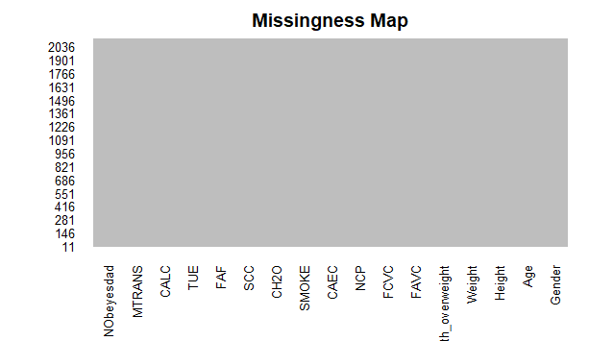
The missingness map of the obese data shows no missing values.
Next up after running the summary() function which tells us the mean value, median value, Q1, Q3, Min and Max value is to run a for loop to get all the box plots, histograms and qq plots of the independent variables against the dependent variables to check for normality.

Density plots, Box plots and Histograms.
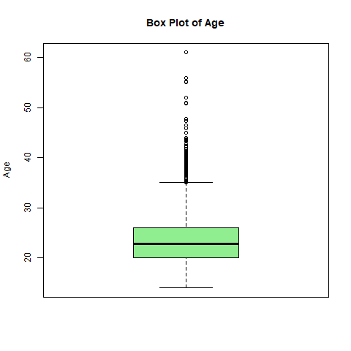
Figure 1Box plot for age
From the box plot of age, we observe several upper outliers which suggest that risk of obesity increases with age as nutritional quality monitoring which babies enjoy from their parents become absent and the adult has the freedom to eat junk food and not exercise.
This problem can be solved by effective gym attendance and observing a healthy nutrition with intermittent fasting.
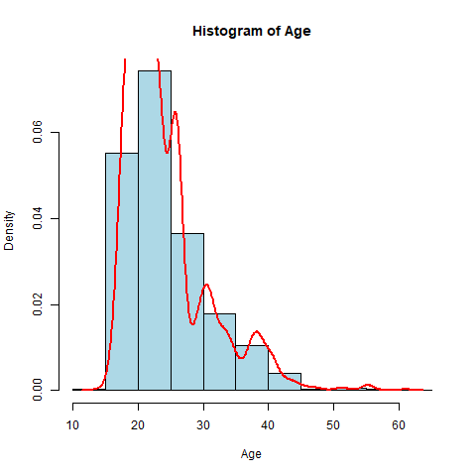
Figure 2 Hist for age
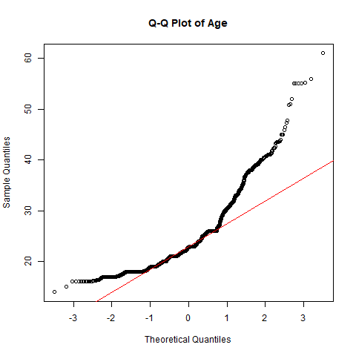
Figure 3 QQ plot for age
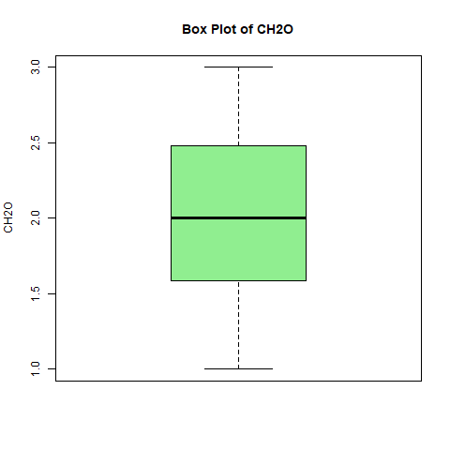
Figure 4 Box plot for water intake
The box plot of water intake shows a normal distribution. It is safe to say that water intake does not affect obesity levels and it might not be a factor variable to consider.
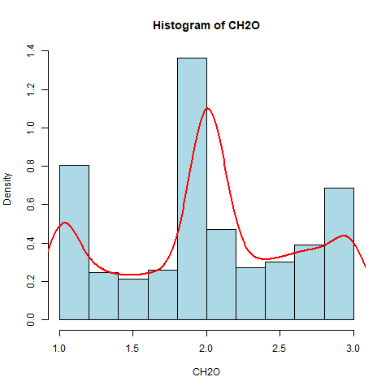
Figure 5 Hist for water consumption
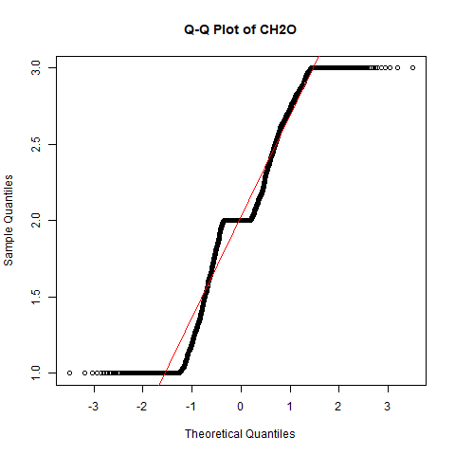
Figure 6 QQ plot for water (CH2O) consumption
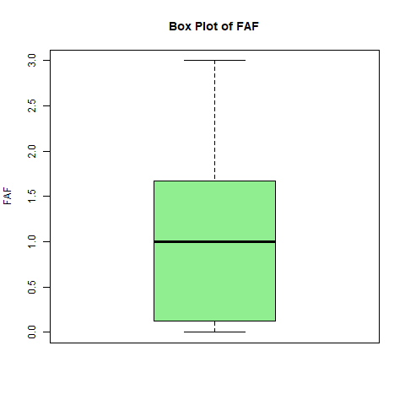
Figure 7 Box plot for physical activity
The box plot of physical activity tells us that lower physical activity levels are associated with higher obesity classes.
This recommends that humans should engage in regular exercise to reduce the risk of obesity.

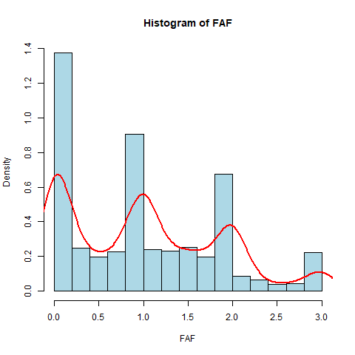
Figure 8 Histogram for physical activity
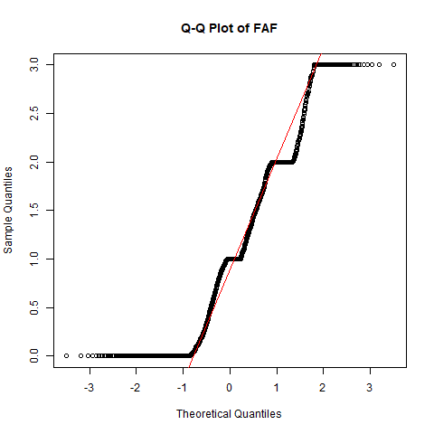
Figure 9 QQ plot for physical activity
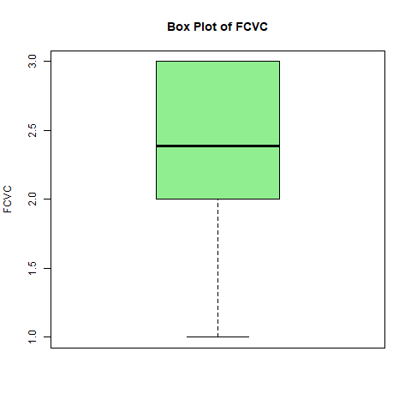
Figure 10 Box plot for vegetable consumption
The box plot of vegetable consumption shows that obesity levels decrease as vegetable consumption increases.
This is a clear indicator that humans should eat more vegetables to reduce the risk of obesity.
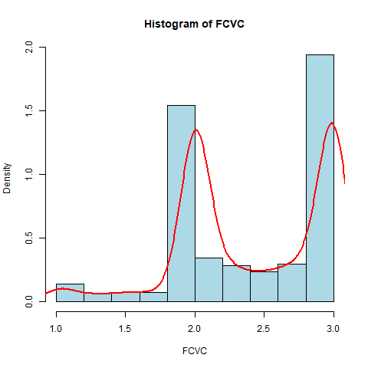
Figure 11Histogram for frequency of consumption of vegetables
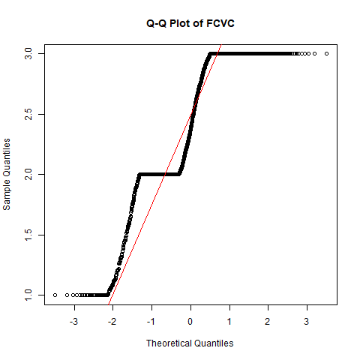
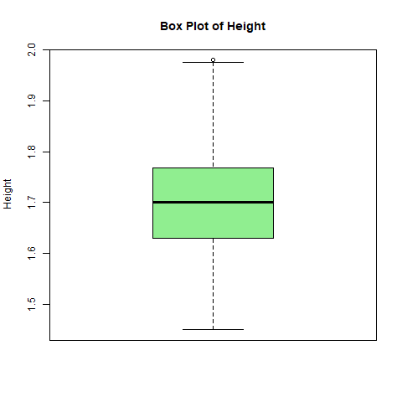
The box plot of height as against obesity shows a normal distribution which tells us that height is not of any direct cause of obesity.
Humans across all heights can be obese if they neglect healthy living.
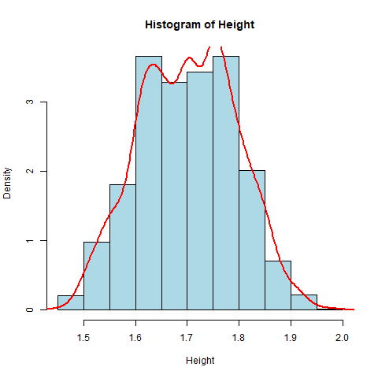
Figure 12 Hist of height

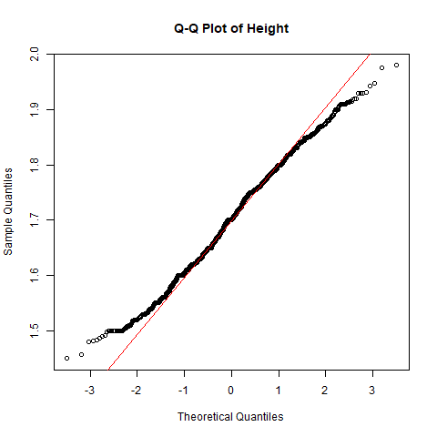
Figure 13 QQ plot of height
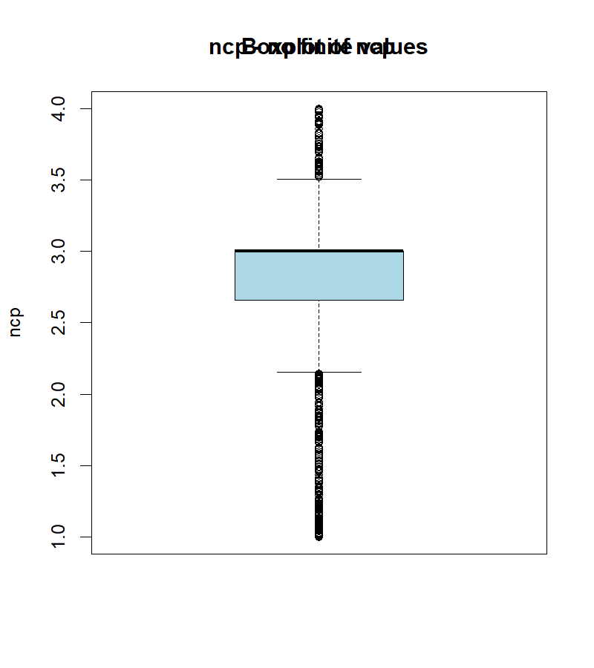
Figure 14 Box plot of Number of main meals
The above box plot of NCP (Number of main meals) shows that people who eat more main meals tend to have higher risk of getting obese.
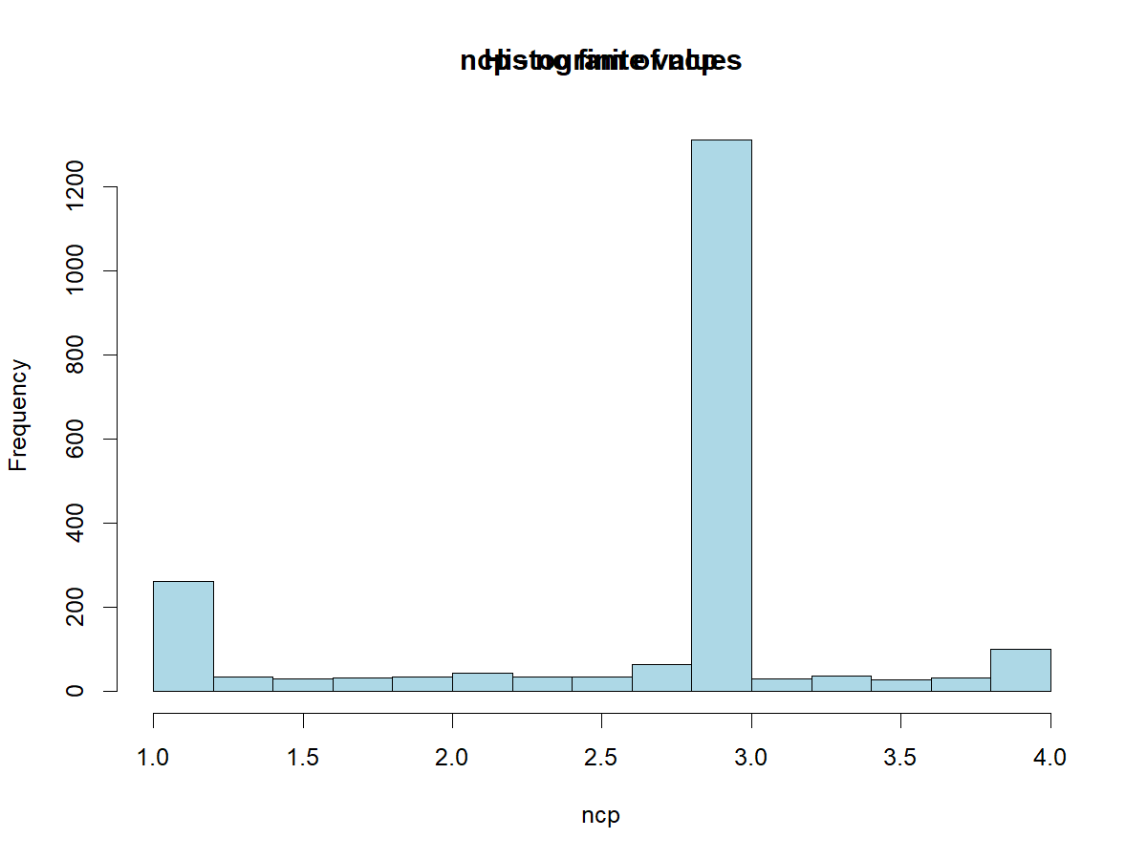
Figure 15 Hist of Number of main meals
The histogram plot for number of main meals shows more clearly that people who eat more main meals (3.0) have higher risk of suffering obesity.
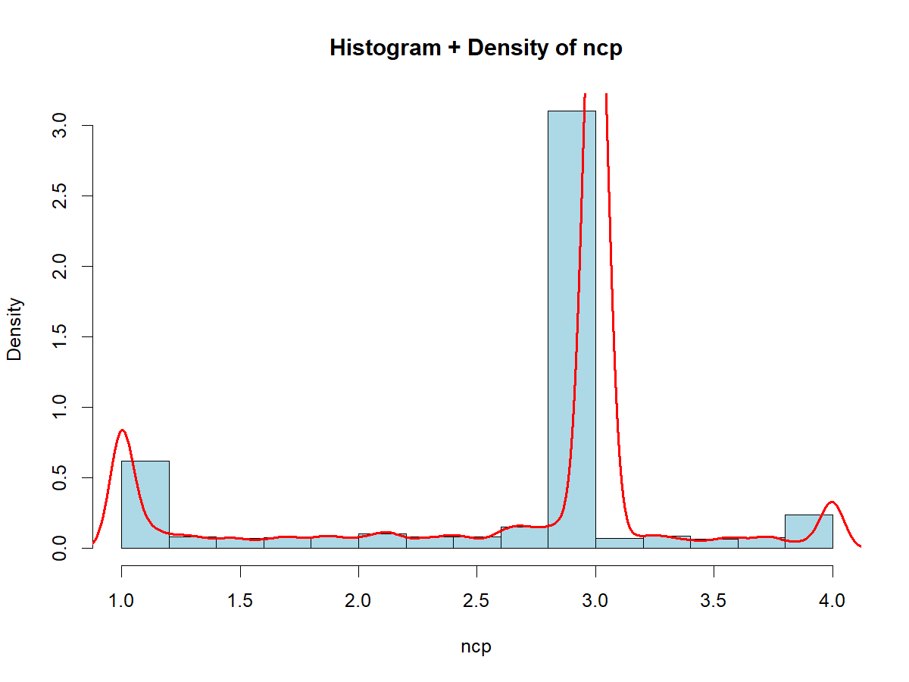
Figure 16 histogram density plot for number of main meals
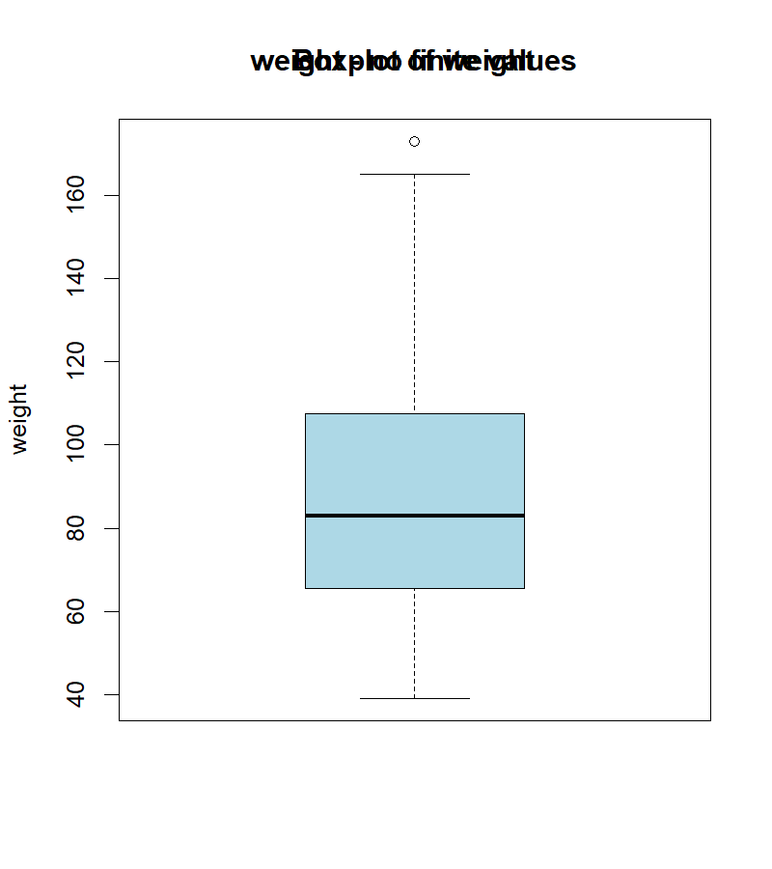
Figure 17 Box plot of weight
The above box plot of weight shows that people with bigger weights (80kg and above) face greater risk of obesity than people who weigh 80kg and below.
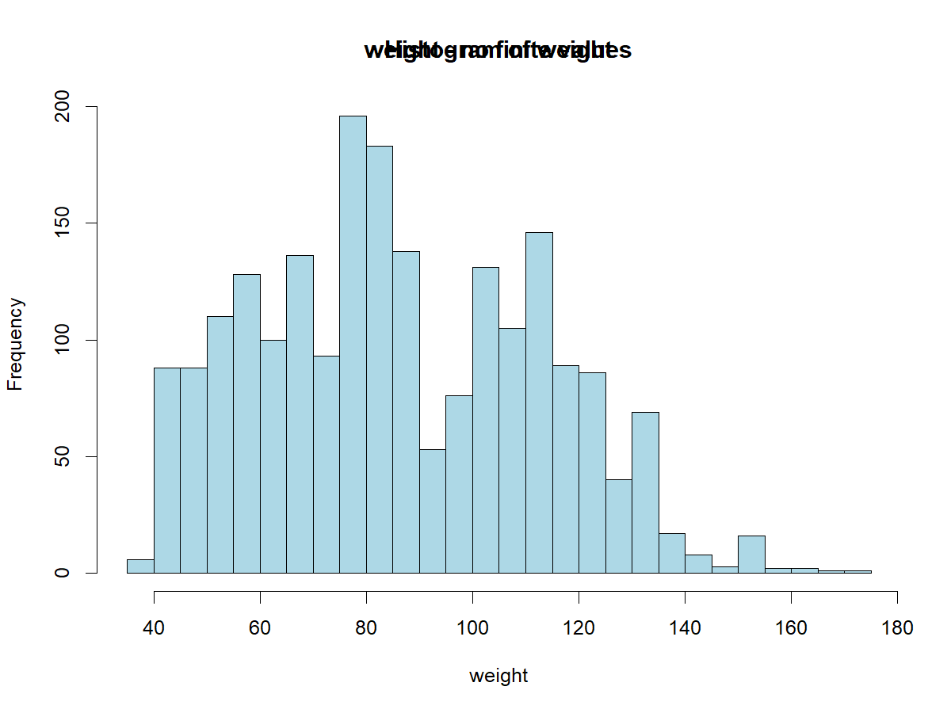
Figure 18 histogram of weight
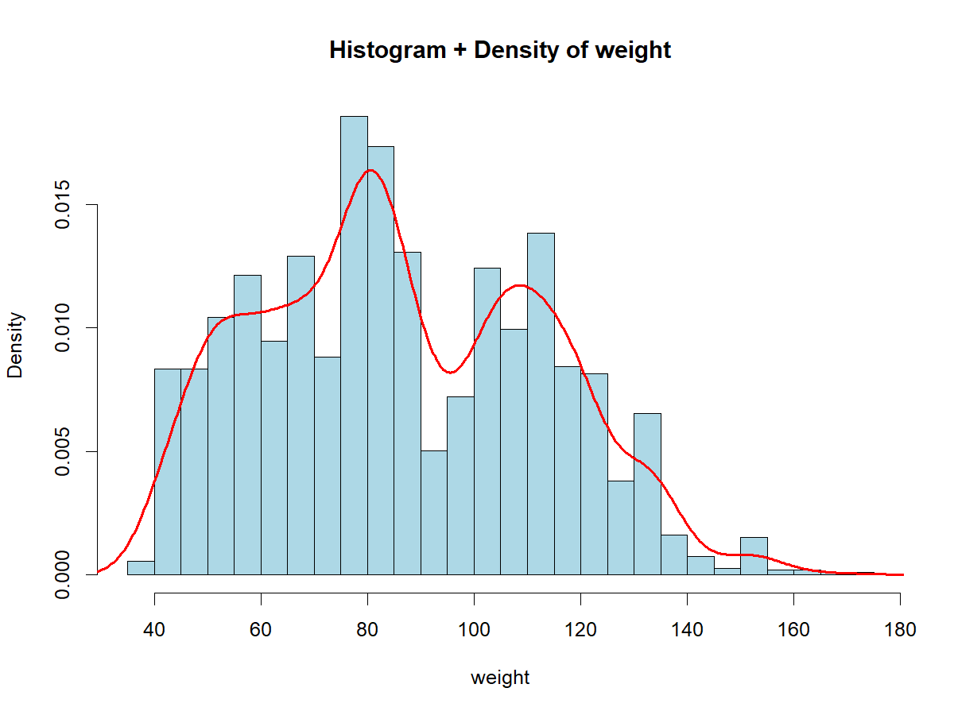
Figure 19 histogram density plot of weight
The histogram density curve of weight shows a clearer insight that obesity risk peaked at people weighing 80-85 kg closely followed by people that weigh 100-120 kg.
More investigations will be carried out.

Correlation heat map.
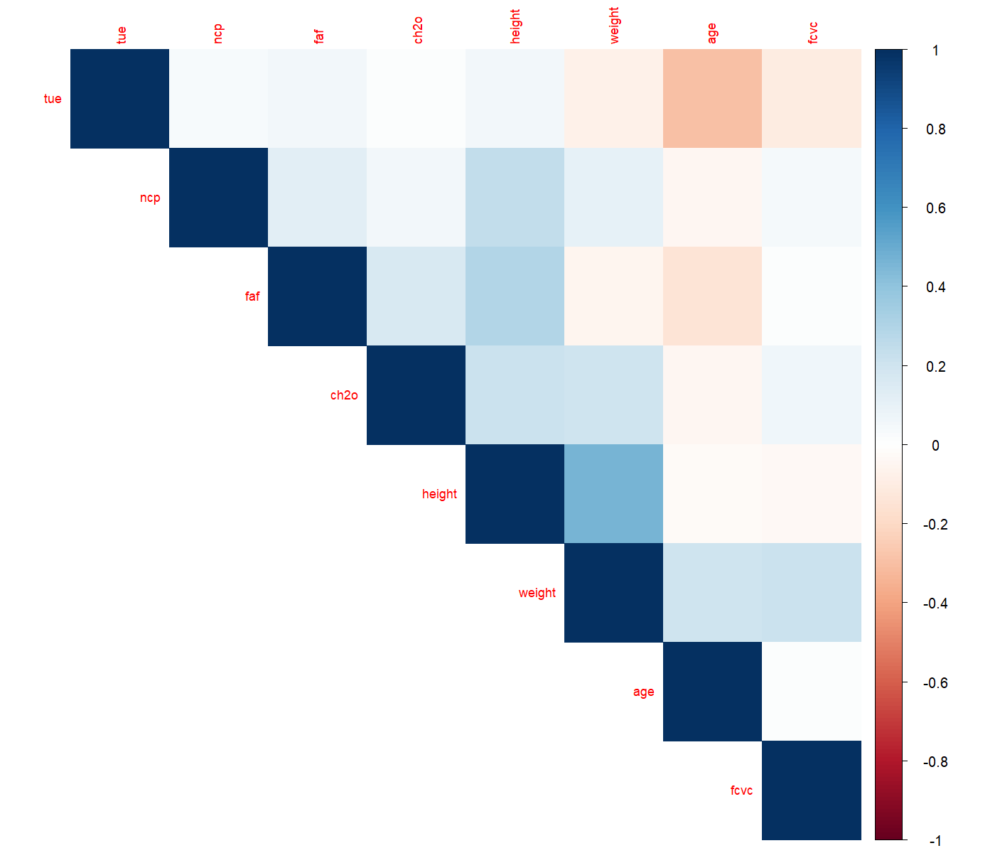
Figure 20 correlation heat map
From the correlation heat map, blue colour shows positive correlation (values closer to +1).
Red colour shows negative correlation (values closer to -1).
Light/white shows weak or no correlation.
Weight shows a strong positive correlation to obesity.
NCP (number of main meals) and FAF (physical activity) shows a moderate positive correlation to obesity. This means that humans must be careful with the number of main meals they eat as eating too much main meals will increase the risk of obesity and not engaging in physical activity will also expose them to the risk of obesity.
Also, discipline is required in engaging in physical activity because the more physical activity one engages in, the more food calories they need to replace energy, and this can lead to obesity.
Height and water intake shows weak negative correlation or no correlation at all.
Partial Correlation Heatmap.
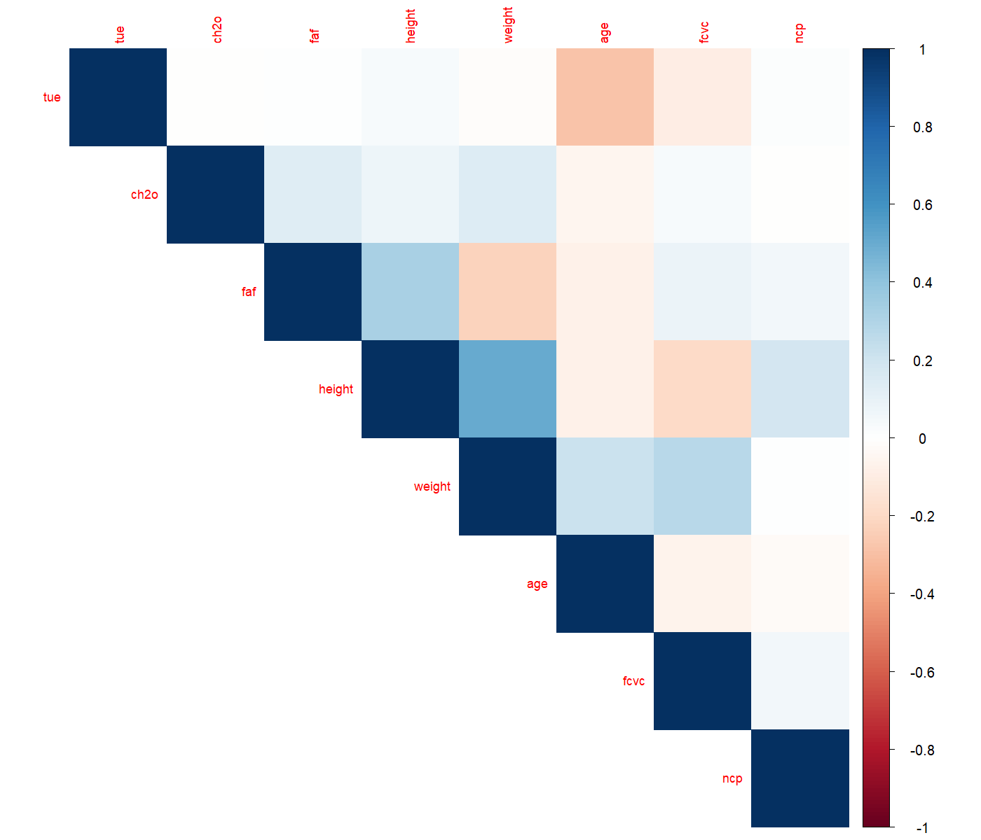
Figure 21 Partial correlation heatmap
From the partial correlation heatmap, we observe that Weight shows strong positive correlation which is a likely indicator that heavier individuals are more likely to fall into higher obesity categories.
Height also shows a moderate positive correlation.
Physical activity (FAF) shows a weak positive correlation.
FCVC (Frequency of Vegetable Consumption) shows a negative correlation. This explains and justifies the phenomenon of the above box plot and histogram plot that people that ate vegetables frequently stood lower risk of getting obese.
CH2O (Daily water consumption) shows a slight negative correlation.
This tells us that drinking more water may be associated with lower obesity levels.
Age and NCP (Number of main meals) show no or very minimal correlation as they appear white.

Principal Component Analysis.
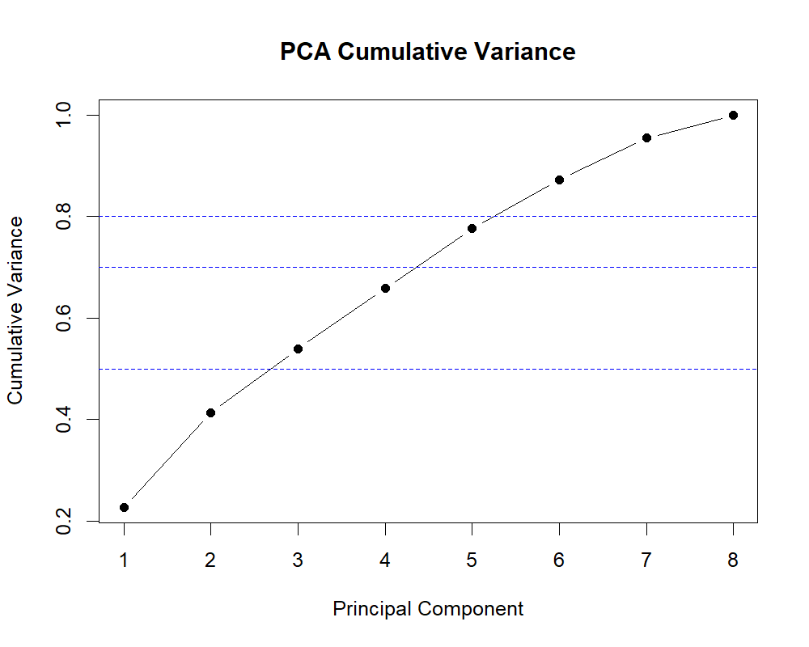
Figure 22 PCA cumulative variance
The PCA Cumulative Variance plot shows how much of the total information (variance) in the obesity dataset is explained as I include more principal components (PCs).

What the graph shows:

X-axis: Principal Components (PC1, PC2, PC3 … PC8)

Y-axis: Cumulative variance explained (from 0 to 1, or 0–100%)

Each point shows the total variance captured when you include components up to that number.

From the graph approximately:

Principal Components Cumulative Variance Explained

PC1 ~22%
PC2 ~40%
PC3 ~53%
PC4 ~65%
PC5 ~77%
PC6 ~87%
PC7 ~95%
PC8 ~100%

What this means for the obesity dataset

1. First few components capture most information

The first 5 components explain about 77% of the dataset variance.

This means most patterns related to obesity can already be represented with 5 variables instead of all original variables.

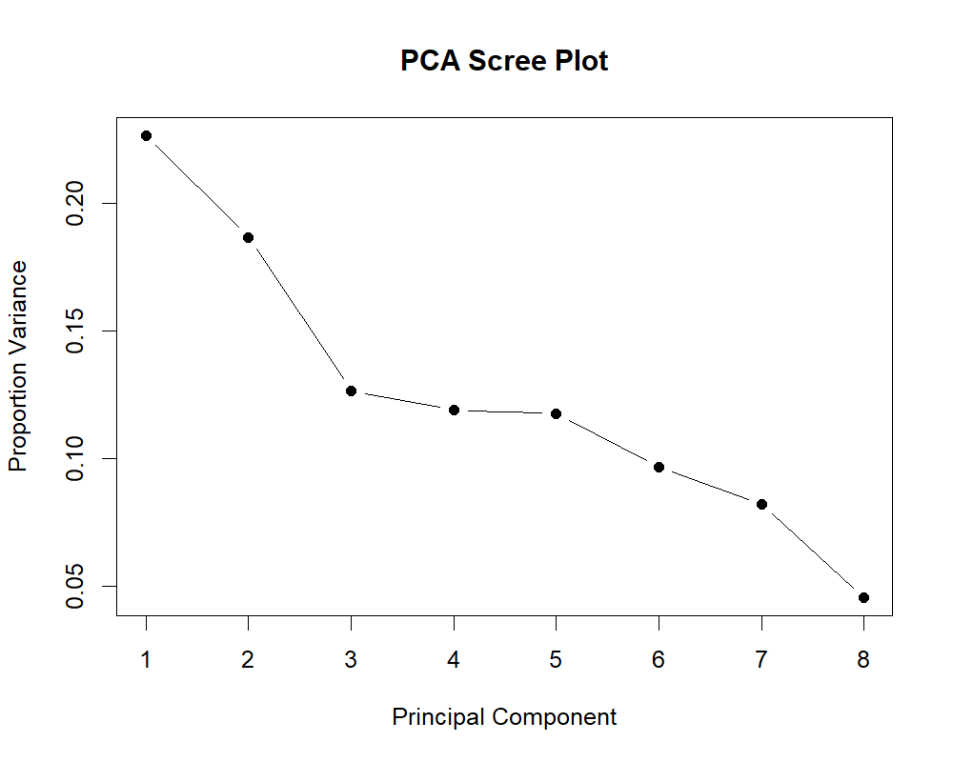
Figure 23 PCA scree plot
The PCA Scree Plot shows how much variance each principal component explains individually in the obesity dataset. It helps determine how many principal components should be kept for analysis.

What the axes represent
- X-axis: Principal Components (PC1 – PC8)
- Y-axis: Proportion of Variance explained by each component

Interpretation of your scree plot
Approximate values from the plot:
Principal Component | Variance Explained
PC1 | ~22%
PC2 | ~19%
PC3 | ~13%
PC4 | ~12%
PC5 | ~12%
PC6 | ~9%
PC7 | ~8%
PC8 | ~5%

Key insights about the obesity dataset
- PC1 explains the largest variance
  - The first principal component captures about 22% of the variation in the dataset.
  - This means it represents the strongest pattern in obesity-related variables.
- Variance gradually decreases
  - Each subsequent component explains less information than the previous one.
- Elbow point
  - The curve starts flattening around PC4 or PC5.
  - This is the elbow point, suggesting that the most meaningful structure in the data is captured by the first 4–5 components.
- Later components add little information
  - Components 6–8 explain small amounts of variance, meaning they contribute less to understanding obesity patterns.

Tukey transformation and Shapiro wilk tests.
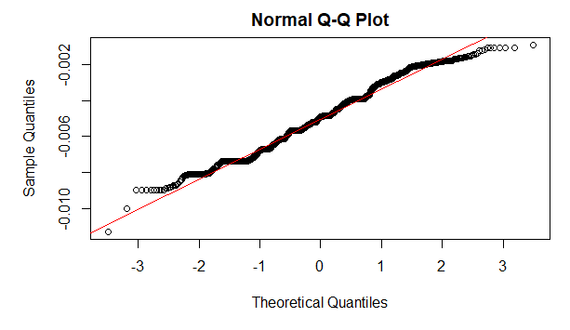
Figure 24 Tukey transformation qq plot
The Tukey transformation QQ plot is used to check whether the transformed variable (age) follows a normal distribution.
The red line which is the reference line shows a perfectly normal distribution.
Obesedata$age <- transformTukey(Obesedata$age)

lambda W Shapiro.p.value
333 -1.7 0.986 1.519e-13

if (lambda > 0){TRANS = x ^ lambda}
if (lambda == 0){TRANS = log(x)}
if (lambda < 0){TRANS = -1 * x ^ lambda}

The shapiro wilk p vale normality test shows that p value< 0.05 which means we reject the null hypothesis and go with the H1 alternative hypothesis which means the data of age is not normally distributed.
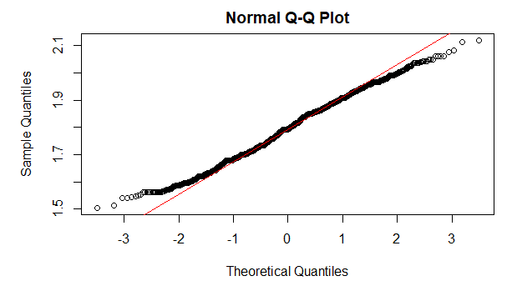
Figure 25 Tukey transformation qq plot for height
The tukey transformation QQ plot for height shows that the red line is away from the 45 degree mark and it is not a normal distribution.
Obesedata$height <- transformTukey(Obesedata$height)

lambda W Shapiro.p.value
445 1.1 0.9933 2.88e-08

if (lambda > 0){TRANS = x ^ lambda}
if (lambda == 0){TRANS = log(x)}
if (lambda < 0){TRANS = -1 * x ^ lambda}

The Shapiro wilk p value < 0.05 so we reject the null hypothesis and we go with the alternative hypothesis which states that the distribution is not a normal distribution.
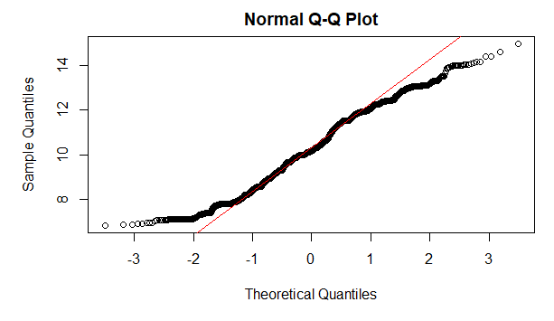
Figure 26 Tukey transformation qq plot for weight
The tukey transformation qq plot for weight shows the red line far off the 45 degree mark and this tells us that the distribution is not a normal distribution.
Obesedata$weight <- transformTukey(Obesedata$weight)

lambda W Shapiro.p.value
422 0.525 0.9814 5.563e-16

if (lambda > 0){TRANS = x ^ lambda}
if (lambda == 0){TRANS = log(x)}
if (lambda < 0){TRANS = -1 * x ^ lambda}

The Shapiro wilk normality test p value< 0.05 meaning we reject the null hypothesis and go with H1 which is the alternative hypothesis which tells us that the distribution is not a normal distribution.
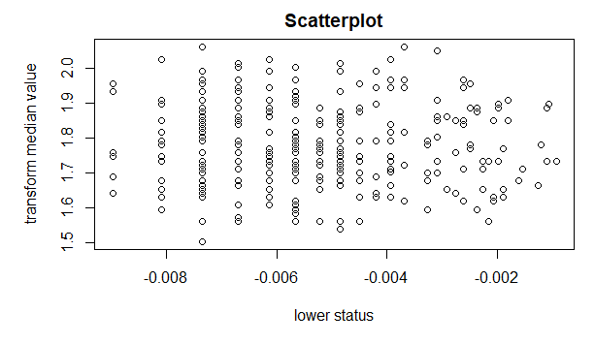
Figure 27 Regression line scatter plot for age and height
The regression line scatter plot between age and height variable shows a normally distributed scatter plot.
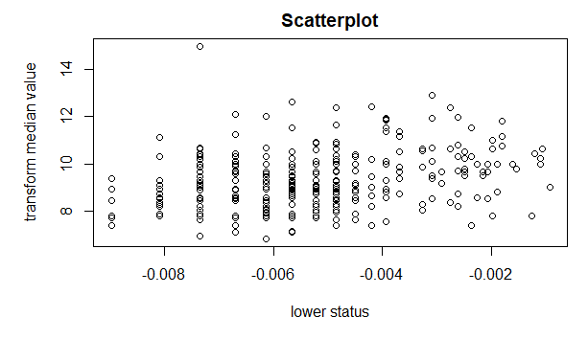
Figure 28 Regression line scatter plot for age and weight
The regression line scatter plot between age and weight variable shows a normally distributed scatter plot.

Summarizing the models.
summary(model1)

Call:
lm(formula = age ~ height, data = Obesedata.tr)

Residuals:
Min 1Q Median 3Q Max
-0.0036225 -0.0013210 -0.0002574 0.0009024 0.0044465

Coefficients:
Estimate Std. Error t value Pr(>|t|)
(Intercept) -0.0050452 0.0015170 -3.326 0.000975 ***
height -0.0001866 0.0008489 -0.220 0.826136
---
Signif. codes: 0 ‘***’ 0.001 ‘**’ 0.01 ‘*’ 0.05 ‘.’ 0.1 ‘ ’ 1

Residual standard error: 0.001803 on 352 degrees of freedom
Multiple R-squared: 0.0001373, Adjusted R-squared: -0.002703
F-statistic: 0.04832 on 1 and 352 DF, p-value: 0.8261

This model tries to determine whether height predicts age in the obesity dataset.

1. Regression Equation

From the coefficients:

Intercept = −0.0050452

Height coefficient = −0.0001866

So the fitted model is:

age = -0.0050452 - 0.0001866(height)

Meaning

The negative coefficient suggests that as height increases, age slightly decreases.

However, the effect is extremely small and not statistically meaningful.

2. Significance of Height (p-value)

For height:

p-value = 0.826

Since:

0.826 > 0.05

 This means height is NOT statistically significant in predicting age.

Interpretation:

There is no evidence of a relationship between height and age in this dataset.

3. R-squared (Model Fit)

Multiple R² = 0.0001373

This means:

Height explains only:

0.0137\%

of the variation in age.

 This is extremely close to zero, meaning the model has almost no explanatory power.

4. F-statistic (Overall Model Significance)

F-statistic p-value = 0.8261

Since:

0.8261 > 0.05

 The entire regression model is not statistically significant.

Meaning:

Height does not help predict age.

5. Residuals

Residuals are small because the transformed age values are very small numbers, but this does not indicate a good model.

The key indicators remain:

High p-value

Very low R²

6. What This Means in Simple Terms

The results tells us that:

Height does not explain age in the obesity dataset.

There is no meaningful linear relationship between the two variables.

The model cannot be used to predict age from height.

Converting nobeyesdad (my target variable) to numeric to enable me run my linear regression models.

Obesedata$nobeyesdad_num <- as.numeric(as.factor(Obesedata$nobeyesdad))
model3 <- lm(nobeyesdad_num ~ age + height + weight, data = Obesedata)
summary(model3)
Call:
lm(formula = nobeyesdad_num ~ age + height + weight, data = Obesedata)

Residuals:
Min 1Q Median 3Q Max
-2.7686 -1.0647 -0.5356 0.2463 3.5322

Coefficients:
Estimate Std. Error t value Pr(>|t|)
(Intercept) 3.07164 1.13777 2.700 0.00717 **
age 117.38652 41.80465 2.808 0.00518 **
height -4.94631 0.76780 -6.442 2.76e-10 ***
weight 1.02817 0.07393 13.908 < 2e-16 ***
---
Signif. codes: 0 ‘***’ 0.001 ‘**’ 0.01 ‘*’ 0.05 ‘.’ 0.1 ‘ ’ 1

Residual standard error: 1.588 on 502 degrees of freedom
Multiple R-squared: 0.3384, Adjusted R-squared: 0.3344
F-statistic: 85.58 on 3 and 502 DF, p-value: < 2.2e-16

The linear regression model examines how age, height, and weight influence the obesity category (nobeyesdad).

Since nobeyesdad was converted to numbers representing increasing obesity levels, a higher value means a higher obesity category.

1. Regression Equation

From the output, the fitted model is:

nobeyesdad =3.07164 + 117.38652(age) - 4.94631(height) + 1.02817(weight)

This equation predicts the obesity level category based on age, height, and weight.

2. Significance of Each Variable

We check p-values (significant if < 0.05).

Variable Coefficient p-value Interpretation

Age 117.39 0.005 Significant
Height -4.95 2.76e-10 Highly significant
Weight 1.03 <2e-16 Extremely significant

Interpretation

 Age (p = 0.005)
Age significantly affects obesity level. As age increases, the obesity category tends to increase.

 Height (p ≈ 0.000000000276)
Height has a negative relationship with obesity category.
This means taller individuals tend to fall into lower obesity categories, holding other variables constant.

 Weight (p < 2e-16)
Weight has the strongest effect.

As weight increases, the obesity category increases.

This makes sense because higher body weight is directly associated with higher obesity levels.

3. Model Fit (R-squared)

R² = 0.3384

This means:

33.84\%

of the variation in obesity category is explained by:

age

height

weight
Interpretation

The model has moderate explanatory power.

There are still other factors influencing obesity such as:

physical activity

diet

lifestyle

genetics

4. Overall Model Significance

F-statistic p-value < 2.2e-16

Since this is far below 0.05:

 The overall regression model is statistically significant.

This means:

Age, height, and weight together significantly predict obesity level.

5. Residual Standard Error

Residual standard error = 1.588

This indicates the average prediction error in the obesity category scale.

6. Key Findings

The model suggests:

 Weight is the strongest predictor of obesity level.
 Age also contributes significantly to obesity classification.
 Height is negatively related to obesity level.
 The model explains about 34% of the variation in obesity categories.

Next up, we will look at Classification model, after which we will compare the two and examine their pros and cons.

Classification model.

For classification model, the obesity level (NObeyesdad) is a factor since I am predicting values like Normal, Overweight and Obesity type, hence my stringsASFactors=TRUE

obesedata <- read.csv("ObesityDataSet_raw_and_data_sinthetic.csv", stringsAsFactors = TRUE)

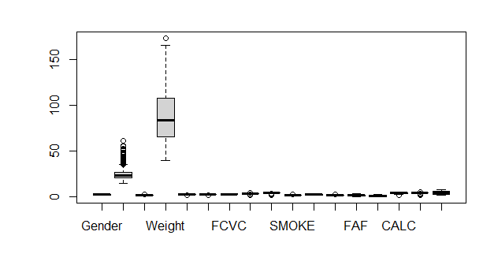
Figure 29 unstandardised boxplot for obesedata
We will yet standardize (or normalise) the box plots of the obese data variables to be able to properly identify outliers or patterns and their meanings.
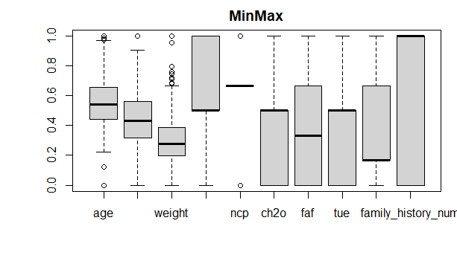
Figure 30 boxplots normalized with minmax
The above box plots for the obese data have been normalized with Min Max scaling, and we can now observe clear outliers in the variables and give interpretation to them.
With the Age variable, we observe upper outliers signifying adults suffering increased obesity risk as they advanced in age. This could partly be due to reduced exercise routine and increased dormancy which leads to fat build up.
With the weight variable, we also observe upper outliers (from 0.7 and above) signifying that more weightier individuals stand a greater risk of obesity.
The TUE box plot indicates time spent on electronic devices which shows variations.
The variations shows that different amounts of times were spent on electronic devices which obviously influence sedentary behaviour which in turn affect obesity levels.
The CH2O box plot shows a variation which indicates different water consumption habits.
The box plot of CH2O is not enough to conclude causation in obesity but as we progress through the classification model, we will discover more insights.

Note that my dataset model was split into 80% training and 20% testing.
Obesedata_train <- Obesedata_mm[1:1690, ]
Obesedata_test <- Obesedata_mm[1691:2111, ]
My Obesity dataset has 2111 rows.
80% training makes for 1690 rows whuke 20% testing makes for 421 rows.
Evaluating the confusion matrix model after implementing the K nearest neighbour’s classification model to get the 5 nearest neighbours.
library(gmodels)
CrossTable(
x = Obesedata_test_labels,
y = knn_model,
prop.chisq = FALSE,
prop.t = FALSE,
prop.r = FALSE,
prop.c = FALSE
)
Cell Contents
|-------------------------|
| N |
|-------------------------|

Total Observations in Table: 421

| knn_model
Obesedata_test_labels | Obesity_Type_I | Obesity_Type_II | Obesity_Type_III | Row Total |
----------------------|------------------|------------------|------------------|------------------|
Obesity_Type_II | 0 | 109 | 0 | 109 |
----------------------|------------------|------------------|------------------|------------------|
Obesity_Type_III | 15 | 47 | 250 | 312 |
----------------------|------------------|------------------|------------------|------------------|
Column Total | 15 | 156 | 250 | 421 |
----------------------|------------------|------------------|------------------|------------------|

The confusion matrix evaluates predictions from my K-Nearest Neighbours classification model based on the 20% test dataset (421 observations).
This means that 421 records from my Obesity dataset were used to test the model after the 80% / 20% split.
Training data = 1684 observations
Testing data = 421 observations.
My rows in the confusion matrix are the Actual Obesity class while my columns are the Predicted Obesity category from the KNN model.
The following results were observed from my matrix.
109 individuals actually belong to Obesity Type 11
The model predicted:
Prediction | Count
Predicted as Obesity Type 11 | 109
Predicted as Obesity Type 111 | 0

This means that the model correctly classified all 109 individuals.
Accuracy for this class = 100%
Obesity Type 111
62 individuals actually belong to Obesity Type 111
Model prediction:
Prediction | Count
Predicted as Obesity Type 11 | 15
Predicted as Obesity Type 111 | 47

This means 47 were correctly classified and 15 were misclassified.
Accuracy for this class : 47/62 = 75.8%. Note that the 62 is gotten from adding 47 to 15.
The KNN model shows high level accuracy in predicting Obesity Type 11.
15 individuals were incorrectly predicted in Obesity Type 111. This may be due to similar lifestyle characteristics among those 15 individuals (diet, physical activity, calorie intake, etc).

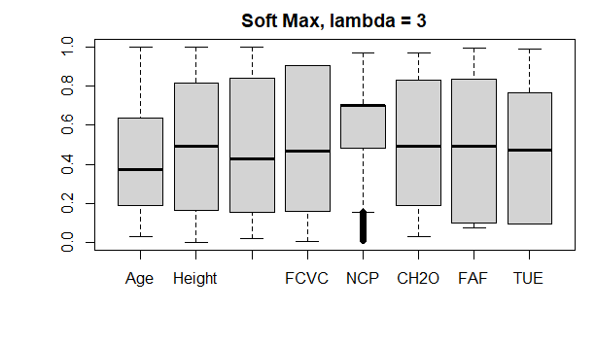
Figure 31 Soft max normalization box plot
From the Soft Max normalization box plot, we observe that some individuals have unusually low number of daily meals compared to the rest of the dataset.
We also notice that the medians generally fall between 0.35 - 0.50.
Soft Max Cross Table.
CrossTable(x = Obesedata_test_labels, y = Obesedata_test_pred, prop.chisq=FALSE)
Cell Contents
|-------------------------|
| N |
| N / Row Total |
| N / Col Total |
| N / Table Total |
|-------------------------|

Total Observations in Table: 421

| Obesedata_test_pred
Obesedata_test_labels | Obesity_Type_I | Obesity_Type_II | Overweight_Level_I | Overweight_Level_II | Row Total |
----------------------|---------------------|---------------------|---------------------|---------------------|---------------------|
Obesity_Type_II | 0 | 109 | 0 | 0 | 109 |
| 0.000 | 1.000 | 0.000 | 0.000 | 0.259 |
| 0.000 | 0.553 | 0.000 | 0.000 | |
| 0.000 | 0.259 | 0.000 | 0.000 | |
----------------------|---------------------|---------------------|---------------------|---------------------|---------------------|
Obesity_Type_III | 115 | 88 | 28 | 81 | 312 |
| 0.369 | 0.282 | 0.090 | 0.260 | 0.741 |
| 1.000 | 0.447 | 1.000 | 1.000 | |
| 0.273 | 0.209 | 0.067 | 0.192 | |
----------------------|---------------------|---------------------|---------------------|---------------------|---------------------|
Column Total | 115 | 197 | 28 | 81 | 421 |
| 0.273 | 0.468 | 0.067 | 0.192 | |
----------------------|---------------------|---------------------|---------------------|---------------------|---------------------|

The Soft Max confusion matrix compares Actual labels: Obesedata_test_labels and Predicted labels: Obesedata_test_pred
Total observations: 421.

We can see that Obesity_Type_11 has a perfect prediction.
From the first row:
Actual | Predicted Obesity_Type_11
109 | 109

109 out of 109 Obesity Type 11 cases were predicted correctly.
Accuracy for this class =100%
This means that the model perfectly identified all Type 11 obesity cases.

We also observe that Obesity Type 111 has poor prediction.
From the second row:
Predicted | Count
Obesity_Type_1 | 115
Obesity_Type_11 | 88
Overweight_Level_1 | 28
Overweight_Level_11 | 81

Actual Obesity Type 111 = 312 people, but: 0 were predicted correctly as Type 111, most were misclassified as Type 1 or Type 11.
This means the model cannot distinguish Type 111 obesity well.

From the overall model performance, we have 109 correct predictions out of 421 total observations.
The accuracy percentage is 25.8 % which is quite low.

Both the Min Max and Soft Max confusion matrices have perfect and imperfect predictions.
In comparing the two models I used in this portfolio (which are Classification and Regression), Classification has some advantages over Regression while Regression also has advantages over Classification.

One notable advantage I noticed from my outputs that Classification has is it’s normalized box plots are more precise and concise and give me better insights to my dataset.

Regression has better advantages because the correlation and partial correlation heatmaps tell stories of the strongest positive and negative correlated variables to the dependent variable.
Also, regression helps us to pick out the principal components and weed out the unnecessary variables during PCA (principal component analysis).

In conclusion, if working on a minimal dataset, classification can fly, but if working on ambiguous datasets, regression is my preferred method.

Next up, we will apply some feature engineering in the classification model to extract better insights in the dataset.
Note that feature engineering is the process of transforming raw data into features by combining two or more variables to better represent the underlying patterns or representing categorical variables with numbers which is a process known as encoding.

Applying feature engineering.
I will create a variable called lifestyle score that will combine variables that represent lifestyle habits.
I will combine FAF (physical activity), TUE(technology use) and CH2O(water consumption)
The interpretation for this is higher score=healthier lifestyle

Obesedata$lifestyle_score <- Obesedata$FAF + Obesedata$CH2O - Obesedata$TUE

Visualizing the lifestyle score with box plot

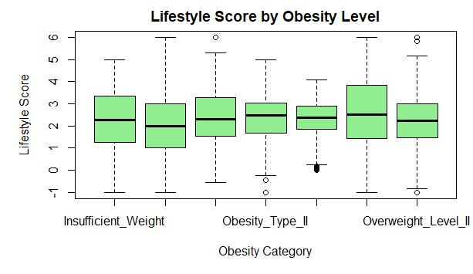
Figure 32 Obesedata lifestyle score boxplot
The lifestyle score box plot shows that lifestyle scores vary across obesity categories.
The median lifestyle score represents the typical value for each obesity group.
The Normal Weight/ Lower obesity levels have medians slightly above 2
The Obesity Type 11 have medians around 2.7 – 3
The Overweight level 11 has medians close to 3

Visualizing the lifestyle score with histogram
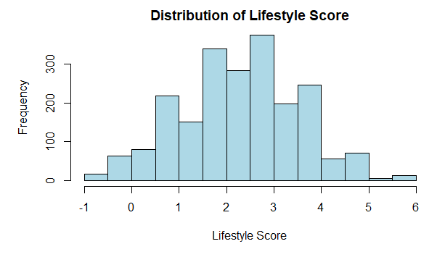
Figure 33 Distribution of lifestyle score histogram
The lifestyle score histogram is reasonably normally distributed.
Most individuals in the dataset have moderate lifestyle scores, suggesting that extreme or unhealthy lifestyles are less common.

The next feature engineering we will do is to combine eating related variables
Higher values will indicate healthier eating habits
We will combine FCVC (vegetable consumption), NCP(number of meals) and CAEC(snacking)
Obesedata$eating_index <- Obesedata$FCVC + Obesedata$NCP

Next up, we visualize the eating behaviour index with a histogram
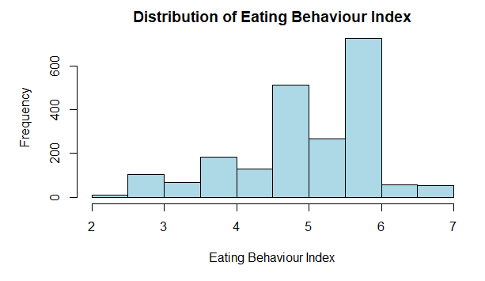
Figure 34 Eating behaviour index histogram
The eating behaviour index histogram tells us that Higher scores = healthier eating habits (more vegetables + structured eating pattern).
Lower scores =poorer eating habits (few vegetables and excessive snacking)
We observe that most people have moderately healthy eating behaviours. The histogram peaks at Eating Index =6.
This means that many individuals consume vegetables regularly (FCVC) and eat 2-3 main meals per day (NCP).

The next feature engineering we will do is compare activity with sedentary behaviour which we will call activity ratio.
Obesedata$activity_ratio <- Obesedata$FAF / (Obesedata$TUE + 1)
The activity ratio represents how physically active someone is relative to their sedentary technology time.
Visualizing it with a histogram helps us understand activity patterns and their relationship with obesity levels
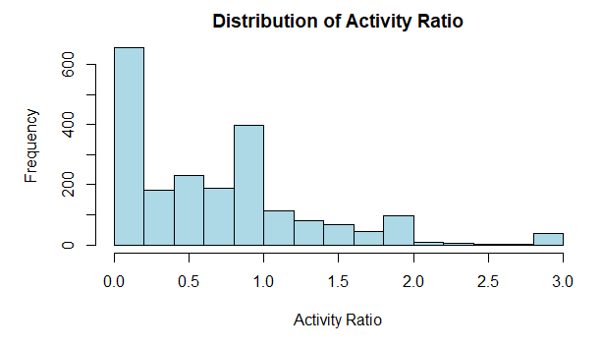
Figure 35 Activity ratio histogram
The activity ratio histogram shows us that most people have low activity ratios. This means many individuals are doing very little physical activity compared to a large amount of sedentary technology time.
Moderate activity ratios are less common (0.5 -1.0)
Higher activity ratios which are individuals who engage in significantly more physical activity than sedentary time are rare (values above 1.0 – 3.0).
We can conclude that physical activity can influence Obesity in two ways:
  - The more people engage in physical activity as per exercise, the more they stay in good shape physically.
  - The more people engage in physical activity as per manual labour (blue collar jobs), the hungrier they get for food which makes them in turn consume excessive calories and get obese.

Chapter 5: Concluding discussion of my findings and a critical reflection of the techniques used.
Conclusion and discussion of findings.
The objective of this research was to examine the major lifestyle, behavioural and physical factors that influence obesity levels using machine learning techniques applied to the obesity dataset. Through exploratory data analysis, regression modelling, classification modelling and feature engineering, several key insights were identified regarding the predictors of obesity.

From the exploratory analysis, it became evident that weight is the strongest predictor of obesity levels, which is consistent with established medical literature where body weight is closely linked to body mass index (BMI), the standard measure for determining obesity. The regression model showed that weight had the most statistically significant impact on the obesity category, indicating that individuals with higher body weight were more likely to fall into higher obesity classes.

Age also showed a statistically significant relationship with obesity levels. As individuals age, the likelihood of moving into higher obesity categories increases. This may be explained by factors such as reduced physical activity, slower metabolic rate, and changes in lifestyle patterns as individuals grow older. The box plots and exploratory analysis supported this finding by showing higher outliers in older age groups.

Height was found to have a negative relationship with obesity classification. Although height itself does not cause obesity, the regression results suggest that taller individuals may be less likely to fall into higher obesity categories when controlling for other variables. However, this relationship should be interpreted cautiously since height alone does not determine body composition.

The exploratory data analysis also revealed several behavioural factors associated with obesity. Physical activity frequency (FAF) showed that individuals with lower levels of exercise were more likely to fall into higher obesity categories. This supports existing research which indicates that sedentary lifestyles contribute significantly to weight gain and obesity development.

Dietary behaviour also played an important role. Higher vegetable consumption (FCVC) was associated with lower obesity risk, while increased number of main meals (NCP) and snacking between meals (CAEC) were associated with higher obesity levels. These findings highlight the importance of dietary quality and eating patterns in weight management.

Water consumption (CH2O) showed only a weak relationship with obesity, suggesting that although hydration contributes to metabolic processes, it may not be a direct determinant of obesity levels in this dataset.

Feature engineering further revealed interesting behavioural patterns. The lifestyle score indicated that individuals with balanced physical activity, lower technology usage, and higher water intake tended to have healthier lifestyle profiles. Similarly, the activity ratio demonstrated that many individuals in the dataset exhibited low physical activity relative to sedentary technology usage, indicating a potential behavioural driver of obesity in modern lifestyles.

Overall, the findings confirm that obesity is a multifactorial condition influenced by physical characteristics, lifestyle habits, and behavioural patterns rather than a single determinant.

Recommendations
Based on the findings from the analysis, several recommendations can be made to help mitigate the risk of obesity.

1. Increase Physical Activity

One of the most consistent findings in the analysis was the relationship between physical inactivity and higher obesity levels. Governments, healthcare providers, and individuals should promote regular physical activity through:

Gym attendance and structured exercise programmes

Daily walking or cycling instead of sedentary transportation

Workplace wellness initiatives encouraging movement during work hours

Regular physical activity improves metabolism, reduces fat accumulation, and enhances cardiovascular health.

2. Promote Healthier Dietary Habits

Dietary behaviour plays a major role in obesity development. Public health campaigns should encourage:

Increased consumption of vegetables and fibre-rich foods

Reduction in high-calorie processed foods

Controlled meal portions and structured mealtimes

Reduced snacking between meals

These interventions can significantly improve nutritional quality and reduce excessive calorie intake.

3. Reduce Sedentary Behaviour

The activity ratio analysis showed that many individuals spend large amounts of time on electronic devices relative to physical activity. Policies and behavioural interventions should therefore aim to:

Reduce excessive screen time

Encourage outdoor recreational activities

Promote active lifestyles among young adults and working professionals

Reducing sedentary behaviour can significantly improve long-term health outcomes.

4. Early Lifestyle Education

Since age was associated with increasing obesity risk, lifestyle education should start early in life. Educational institutions should incorporate:

Nutrition education programmes

School sports and physical activity initiatives

Awareness campaigns about healthy lifestyle choices

This early intervention approach can reduce obesity prevalence later in adulthood.

5. Personalised Health Monitoring

Individuals should monitor their health behaviours such as calorie intake, physical activity levels, and body weight. Technologies such as fitness trackers and mobile health applications can help individuals maintain awareness of their lifestyle patterns and make informed health decisions.

Critical Reflection on the Techniques Used

This study applied two machine learning approaches: regression analysis and classification modelling. Each method provided valuable insights but also had certain limitations.

Regression: Strengths and Limitations

Advantages of Regression in This Study

Regression analysis was particularly useful for understanding relationships between variables. It allowed the study to quantify the impact of predictors such as age, height and weight on obesity levels.

The regression model also provided statistical measures such as:

p-values for significance testing

R-squared for explanatory power

regression coefficients for direction and magnitude of relationships

These metrics allowed the identification of the most influential predictors in the dataset. Additionally, regression techniques facilitated the use of correlation heatmaps and partial correlation analysis, which helped visualise relationships between variables.

Regression also supported principal component analysis (PCA), which helped identify the most important components explaining variance in the dataset. This dimensionality reduction process helped simplify the dataset while retaining most of the useful information.

Limitations of Regression

However, regression models assume linear relationships between variables, which may not always represent real-world behavioural patterns. Obesity is influenced by complex nonlinear interactions between lifestyle, genetics and environmental factors, meaning linear regression may oversimplify these relationships.

Another limitation observed in this study was the moderate R-squared value (approximately 33.8%), indicating that the regression model explains only part of the variation in obesity levels. This suggests that other important factors not included in the dataset may also influence obesity outcomes.

Classification: Strengths and Limitations

Advantages of Classification

The classification approach using K-Nearest Neighbours (KNN) allowed the model to categorise individuals into specific obesity classes. This method is useful when the objective is prediction rather than explanation.

Classification models also provide practical evaluation tools such as confusion matrices, which allow researchers to assess prediction accuracy across different classes. In this study, the classification model performed very well in identifying Obesity Type II cases, achieving perfect prediction for that category in the confusion matrix.

Additionally, classification methods are often effective for complex datasets where multiple variables interact in nonlinear ways.

Limitations of Classification

Despite these strengths, the classification model also showed limitations. In the Softmax confusion matrix, the model struggled to correctly classify Obesity Type III, with many misclassifications into other categories. This resulted in a relatively low overall accuracy in some cases.

Another limitation is that classification models generally focus on prediction rather than interpretation. Unlike regression, classification methods do not easily explain the strength or direction of relationships between variables.

Furthermore, classification performance can be sensitive to factors such as:

feature scaling, training/testing split, choice of K value in KNN and imbalance in class distributions. These factors can significantly influence model accuracy.

Overall Reflection

The combination of regression and classification techniques provided a more comprehensive understanding of the obesity dataset. Regression offered insights into the statistical relationships between predictors and obesity levels, while classification enabled prediction of obesity categories based on behavioural and physical characteristics.

Using both approaches together strengthened the analysis by allowing both explanatory insights and predictive modelling. However, the results also highlight the complexity of obesity as a public health issue influenced by multiple interacting factors.

References:

Adnan, D., Trinh, J. and Bishehsari, F., 2022. Inconsistent eating time is associated with obesity: A prospective study. *EXCLI Journal*, 21, pp.300–306. Available at: [https://doi.org/10.17179/excli2021-4324](https://doi.org/10.17179/excli2021-4324).

Boulé, N. and Prud’homme, D., n.d. *Canadian Adult Obesity Clinical Practice Guidelines: Physical Activity in Obesity Management*. Available at: [https://obesitycanada.ca/wp-content/uploads/2025/03/9-Canadian-Adult-Obesity-CPG-Physical-Activity.pdf](https://obesitycanada.ca/wp-content/uploads/2025/03/9-Canadian-Adult-Obesity-CPG-Physical-Activity.pdf).

Cancerobesityconnection.org, 2025. *The History of Obesity*. Available at: [https://cancerobesityconnection.org/the-history-of-obesity/](https://cancerobesityconnection.org/the-history-of-obesity/) [Accessed 10 Mar. 2026].

Ellis, R.R., 2025. *Does Drinking Water Help You Lose Weight?* WebMD. Available at: [https://www.webmd.com/obesity/drinking-water-lose-weight](https://www.webmd.com/obesity/drinking-water-lose-weight) [Accessed 10 Mar. 2026].

Healthline, 2024. *Smoking May Contribute to Increased Belly Fat*. Available at: [https://www.healthline.com/health-news/smoking-may-lead-to-weight-gain-increased-belly-fat](https://www.healthline.com/health-news/smoking-may-lead-to-weight-gain-increased-belly-fat) [Accessed 10 Mar. 2026].

NIHR Evidence, n.d. *Diet, Obesity and Nutrition Research*. Available at: [https://evidence.nihr.ac.uk/nihrcategory/diet-obesity-nutrition/](https://evidence.nihr.ac.uk/nihrcategory/diet-obesity-nutrition/) [Accessed 10 Mar. 2026].

NCOA.org, 2025. *How Does Obesity Affect Aging?* Available at: [https://www.ncoa.org/article/4-surprising-ways-obesity-affects-aging/](https://www.ncoa.org/article/4-surprising-ways-obesity-affects-aging/) [Accessed 10 Mar. 2026].

Obesity UK, 2024. *What is Obesity?* Available at: [https://obesityuk.org.uk/what-is-obesity/](https://obesityuk.org.uk/what-is-obesity/) [Accessed 10 Mar. 2026].

Appendix:
7003 Final Regression R script.txt

7003 Final Classification R script.txt

ObesityDataSet_raw_and_data_sinthetic.xlsx

